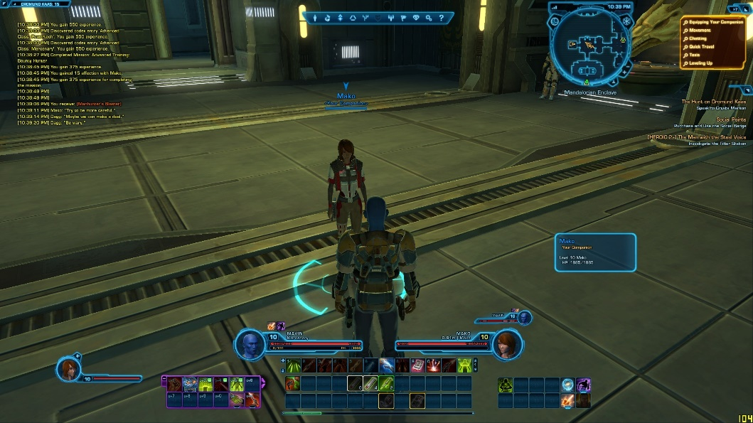Warrenbound: U.I and Menus

This document will go over the U.I, its presentation, and various game menus

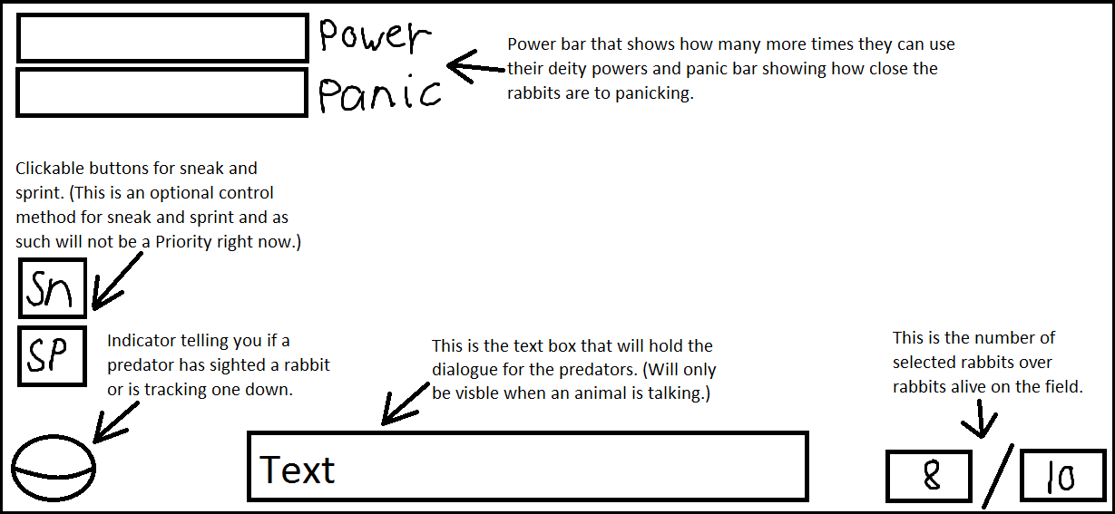

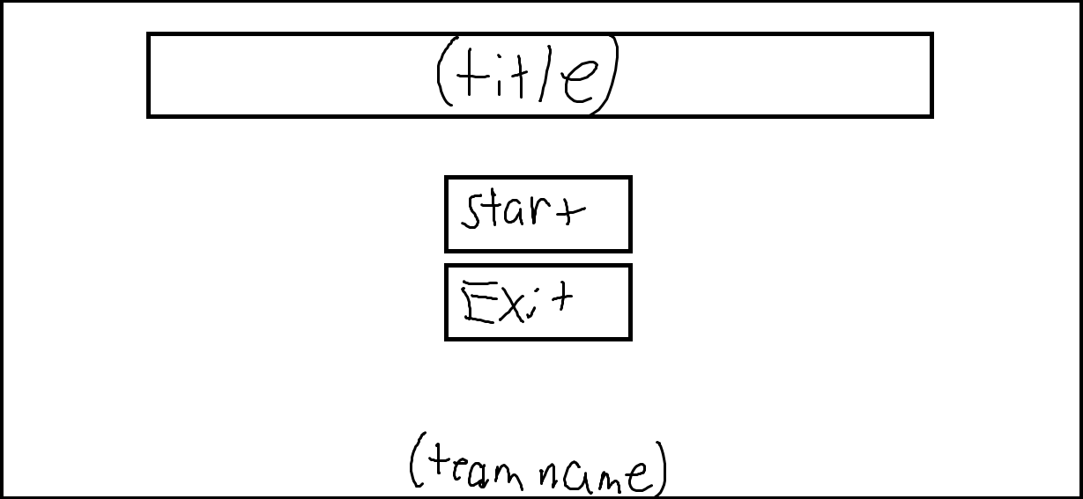

Basic title screen

Other Menus

Other menus and options will be something that will be added at a later date if we have the time. For now, let’s stick with the title screen and main U.I and if time allows towards the end add an options menu.

When Pausing the game

When the player pauses the game the screen should be dimmed slightly, the music should be lowered, and paused should be displayed in the center of the screen.